**Complete process and flow:**

1. We cab export the app from git hub
2. To access voting, result app via app.py

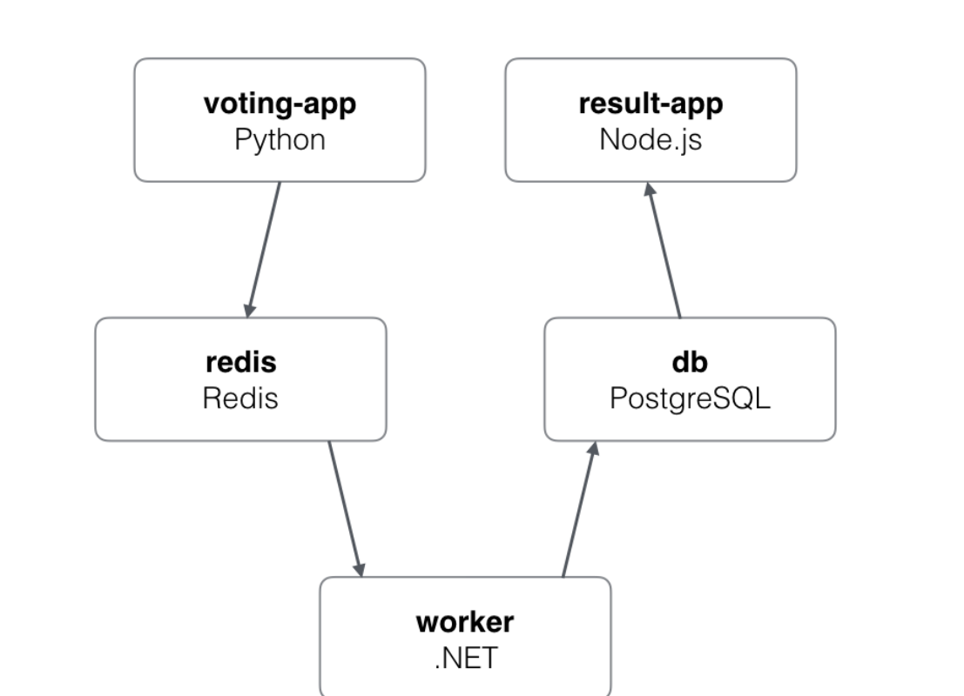

**Flow of data:**

1. Voting app pushing data to Redis app
2. Worker pull data from Redis
3. Worker pushes the data to db

Note: Redis and db are resting and just to store data

2. git clone <https://github.com/ashishrpandey/example-voting-app>

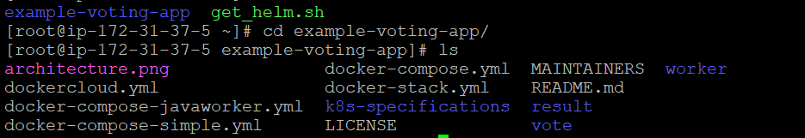

3. & 4. [root@ip-172-31-37-5 k8s-specifications]# **kubectl apply -f .**

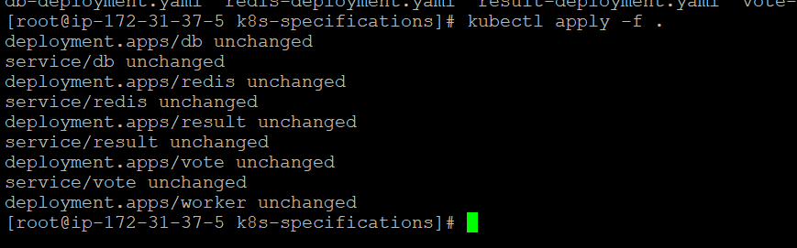

**5. For voting and result pods, Observe that NodePort is assigned.**  
**Vote-service.ymal**  
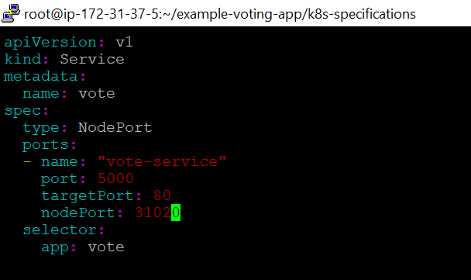

**result-service.ymal**

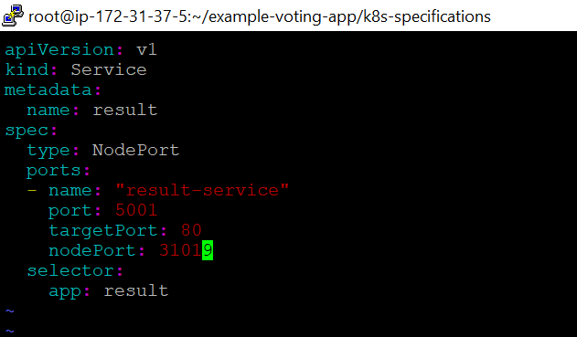

**6. Take your publicIP (your instance IP) : NodePort ► open 2 browsers , one for VOTING and one for Results.**

**Try voting and see the results paralelly in results page.**  
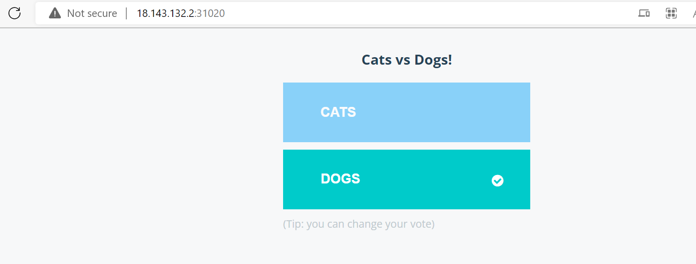

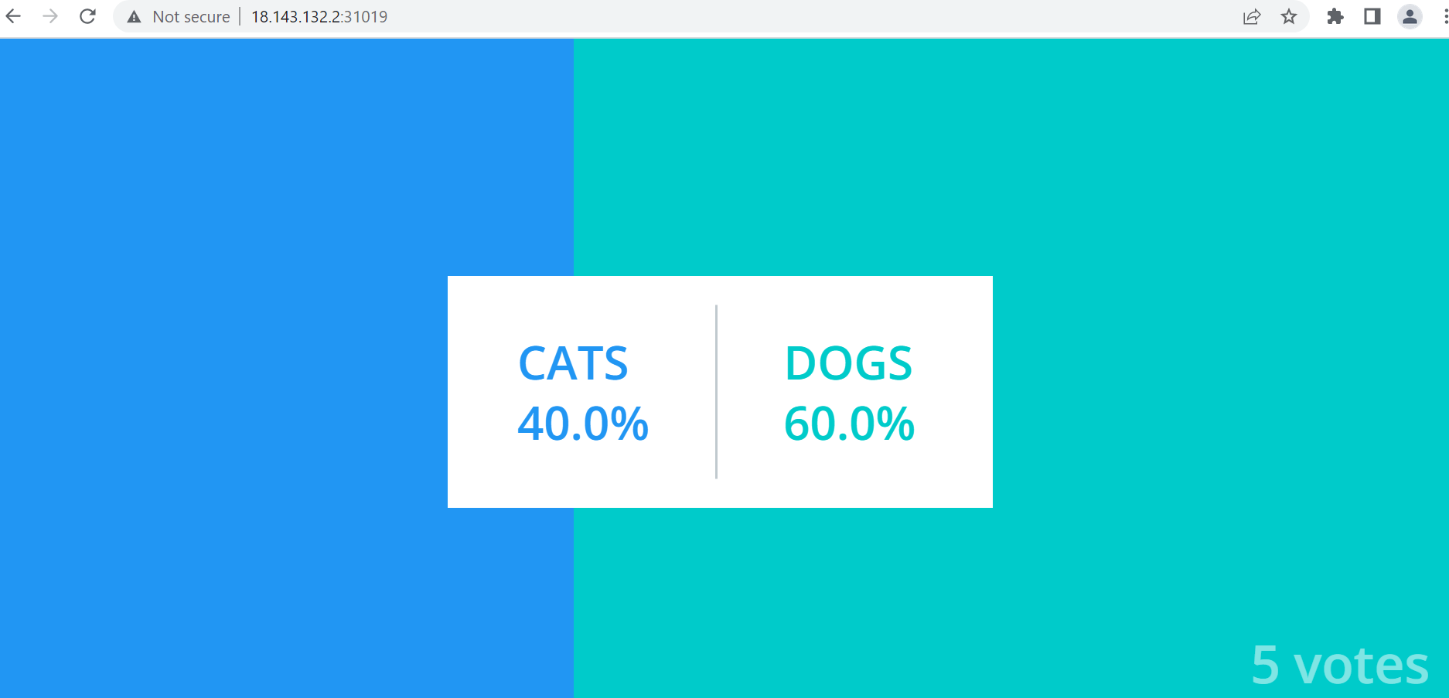

**Vote pod deleted and again recreated, but vote app working fine  
AND replica set changed**

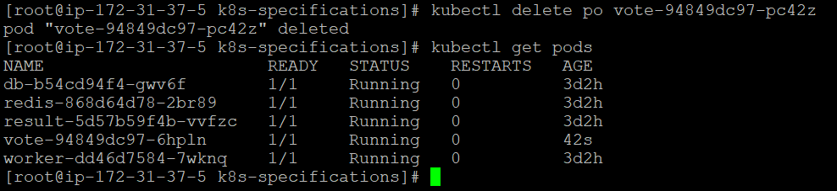

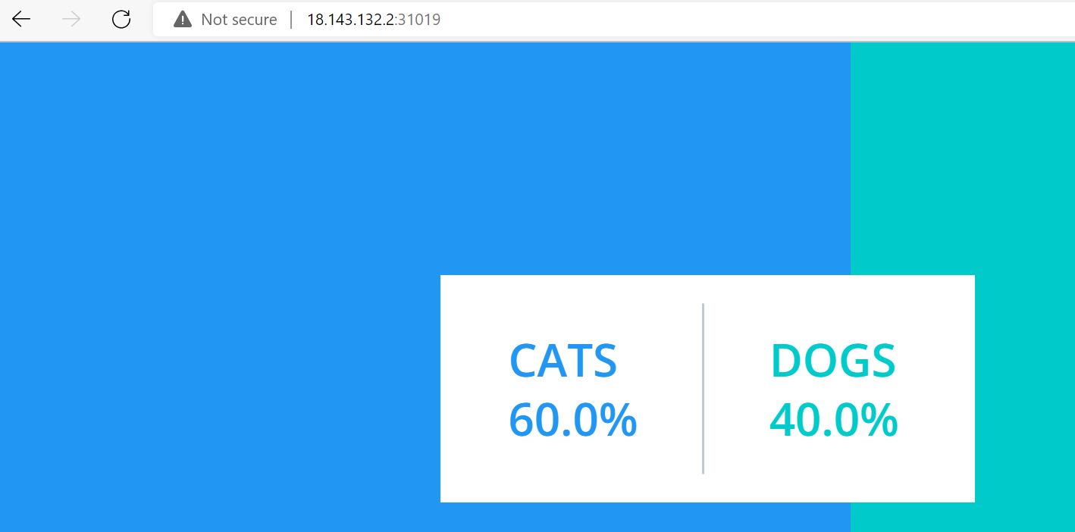

**Worker pod deleted and again recreated, but vote and result app working fine  
AND replica set changed**

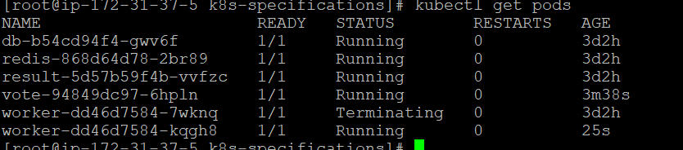

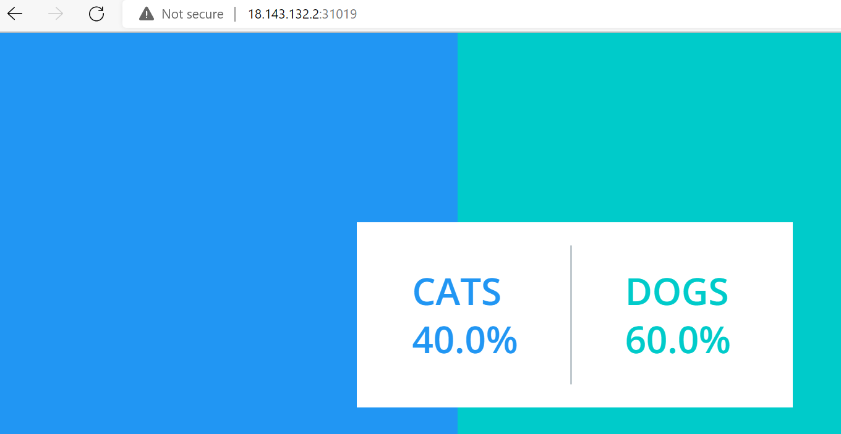

11. complete the assignment by making the result pod work. (if you delete db pod, results would not be captured.So repeat what we did in the class in order to make the result pod work.).

**DB pod deleted and again recreated, but result not showing  
AND replica set changed**

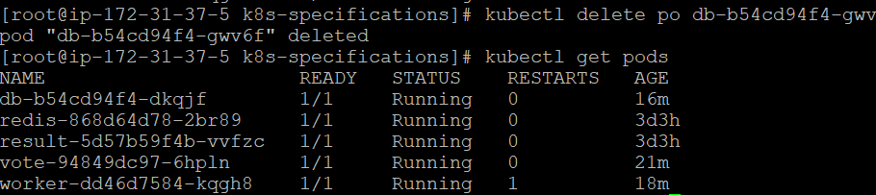

12. **To make it work we need to redeploy result pod**

